
Thorndon School
2026
Stationery Requirements List For
Students in Kereru (Years 3-4), Kakapo (Years 5-6) and
Kea (Years 7-8)

To make life easier for you for Back to School stationery, we have teamed up with Office Max so that you can buy all your school stationery needs over the internet.
The stationery will be delivered to your home or a designated address by courier. This system will mean that ordering is quick and easy, stationery lists will not be lost and products will be of high quality. Payment is by credit/debit card (on-line).
It is recommended that you purchase all your stationery by the 20th of January to ensure delivery before school starts and to give you time to cover books if necessary.
Ordering On-line with Office Max:
- Go to www.myschool.co.nz and enter Thorndon School.
- Select the preferred method of shopping ‘Order using Quick & Easy grid’.
- Select Subject/Year levels required.
- If you want to view what you have ordered then click the ‘Save and Continue Button’. It is advisable not to remove items unless you are sure you already have these items e.g. a ruler, or sharpener that you plan to use from last year.
- At this point you can also order additional items you require e.g. book covering, headphones, drink bottle, etc.
- When you have finished ordering your items click ‘Add these items to Cart’.
- You can check your purchases by clicking ‘View Cart’, then ‘Continue to Checkout’ and follow instructions.
- If some items are unavailable when you place your order then these items will be put on backorder and delivered to you as they arrive. It will be indicated on your delivery docket.
- Print a copy of your order and retain it for your records. Note the order number. This is required in case you need to return items.
Conditions:
- Allow up to 10 working days for delivery, order early and select a delivery window to suit.
- Any problems call Office Max on 0800 724 440, not the school.
- Incorrect items can only be returned through first contacting the customer service team. Returned items must be in good condition. You will need to quote your order number. Returned goods will not be accepted more than 3 months after purchase.

Alternatively, you can print out a copy of your child’s stationery list and go shopping at your favourite stationery shop.
We trust that these systems will make the start of the year simple and efficient.

2026 Stationery Requirements List for Year 3 & 4 (Kereru)
Essential Items | Picture Description | QUANTITY
Warwick My Topic Book 1 or Taka Pukapuka Kaupapa 1 (Unruled 100gsm 64 pages) | 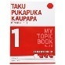 | 1
Warwick My Maths Book 1 or Taka Pukapuka Pangarau 1 (Unruled 100gsm 64 pages) | 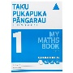 | 2
Warwick LWB Learn to Write Exercise Book (14mm Ruled 32 pages) | 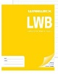 | 2
Warwick 1F8 Exercise Book (12mm Ruled 32 pages) | 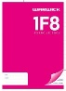 | 2
Warwick 1F4 Exercise Book (12mm Ruled 24 pages) | 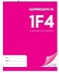 | 4
A3 Spiral Visual Diary (50 leaves) | 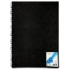 | 1
Scrapbook Ruled (330 x 230 mm 23 leaves) | 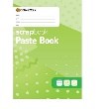 | 2
Blue Ballpoint Pen Medium Tip | 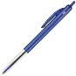 | 3
Green Ballpoint Pen Medium Tip | 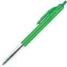 | 2
Plastic Ruler 30 cm | 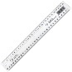 | 1
HB Lead Pencil | 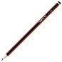 | 12
Sharpie permanent marker | 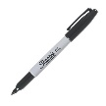 | 2
Whiteboard markers | 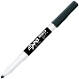 | 2
Pencil Sharpener | 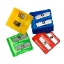 | 2
Large Glue Stick | 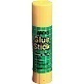 | 4
Vinyl Eraser Large | 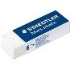 | 2
Protractor | 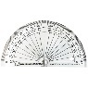 | 1
Compass | 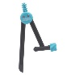 | 1
Highlighter (pack of four) | 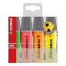 | 1
Coloured Pencils Pack | 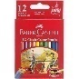 | 1
Felt Tip Markers Assorted Colours Pack | 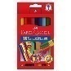 | 1
Pencil Case |  | 1
Scissors |  | 1
Box of tissues | 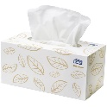 | 1

2026 Stationery Requirements List for Year 5 & 6 (Kakapo)
Essential Items | Picture Description | QUANTITY
Warwick My Writing Book 3 Taku Pukapuka Tuhituhi Exercise Book (9mm ruled) | 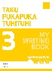 | 2
Warwick My Topic Book 3 Taku Pukapuka Kaupapa (9mm Ruled alternating Unruled pages) | 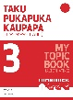 | 3
Warwick My Handwriting Book 1 Taku Pukapuka Tuhi A-Ringa (14mm ruled with a dotted middle line) | 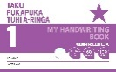 | 4
Warwick My Maths Book 2 (7mm quad) | 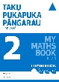 | 2
A5 Spiral Visual Diary (50 Leaves) | 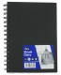 | 1
HB Lead Pencil |  | 12
Green Ballpoint Pen Medium Tip |  | 2
Sharpie permanent marker |  | 2
Whiteboard markers |  | 2
Plastic Ruler 30 cm |  | 1
Highlighter (pack of four) |  | 1
Pencil Sharpener | 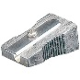 | 2
Large Glue Stick |  | 4
Vinyl Eraser Large |  | 2
Scissors |  | 1
Protractor |  | 1
Compass |  | 1
Box of tissues |  | 1
Headphones |  | 1
Chromebook (Lenovo is a trusted brand but any brand would be acceptable.) |  | 1

2026 Stationery Requirements List for Year 7 & 8 (Kea)
Essential Items | Picture Description | QUANTITY
Warwick My Writing Book 3 or Warwick Taku Pukapuka Tuhituhi 3 (9mm Ruled 64 Pages) | 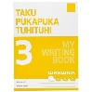 | 2
A4 Spiral Visual Diary 50 Leaves |  | 1
Warwick My Maths Book 2 or Warwick Taku Pukapuka Pangarau 2 (7mm Quad 64 Pages) | 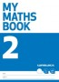 | 2
Warwick My Topic Book 1 or Taka Pukapuka Mahi 1 (Unruled 100gsm 64 pages) |  | 2
Black Ballpoint Pen Medium Tip | 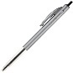 | 3
Blue Ballpoint Pen Medium Tip |  | 3
Red Ballpoint Pen Medium Tip | 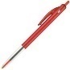 | 1
Green Ballpoint Pen Medium Tip |  | 2
Metal Ruler 30 cm | 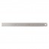 | 1
HB Lead Pencil |  | 5
Sharpie permanent marker |  | 1
Large Glue Stick |  | 4
Vinyl Eraser Large |  | 1
Pencil Sharpener (metal) |  | 2
Coloured Pencils Pack |  | 1
Felt Tip Markers Assorted Colours Pack |  | 1
Scissors |  | 1
Highlighters (set of four) |  | 1
Headphones |  | 1
Chromebook (Lenovo is a trusted brand but any model would be acceptable.) |  | 1

